Menú de Inicio: Como vemos tenemos varias opciones que iremos probando de una en una.

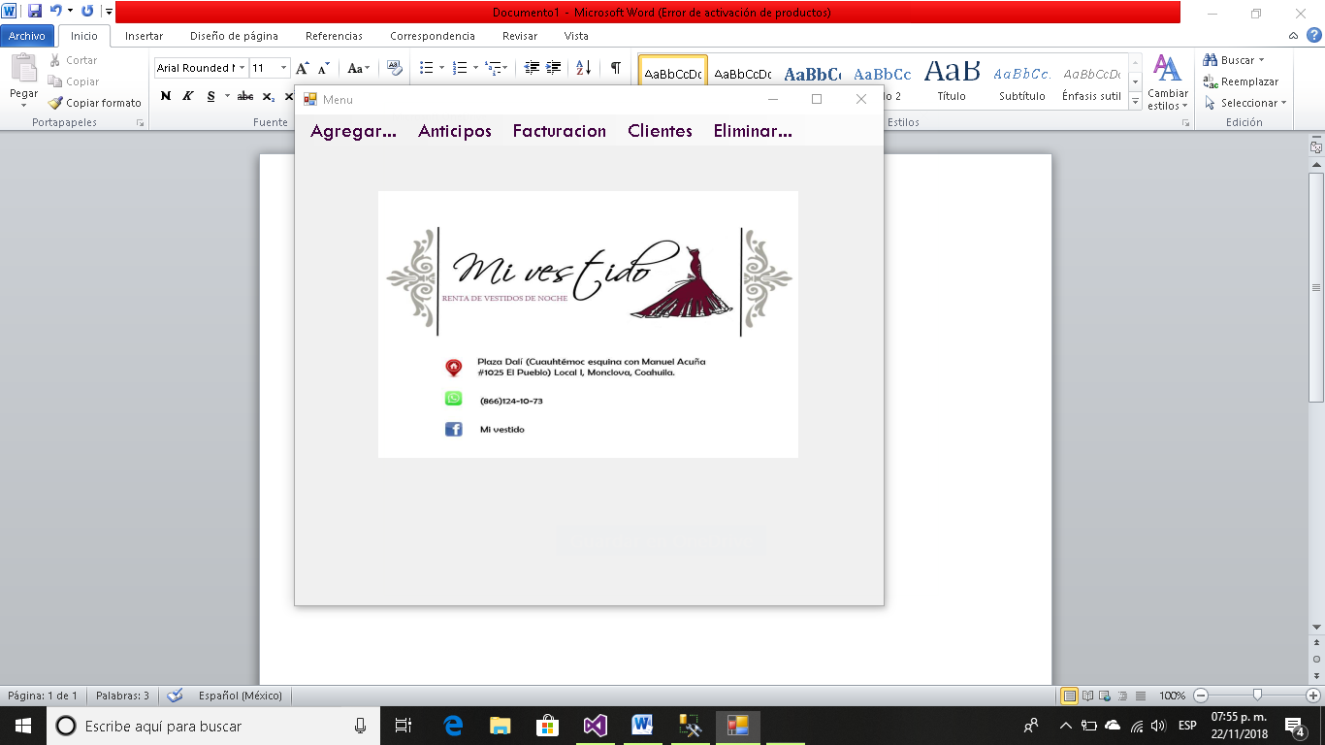

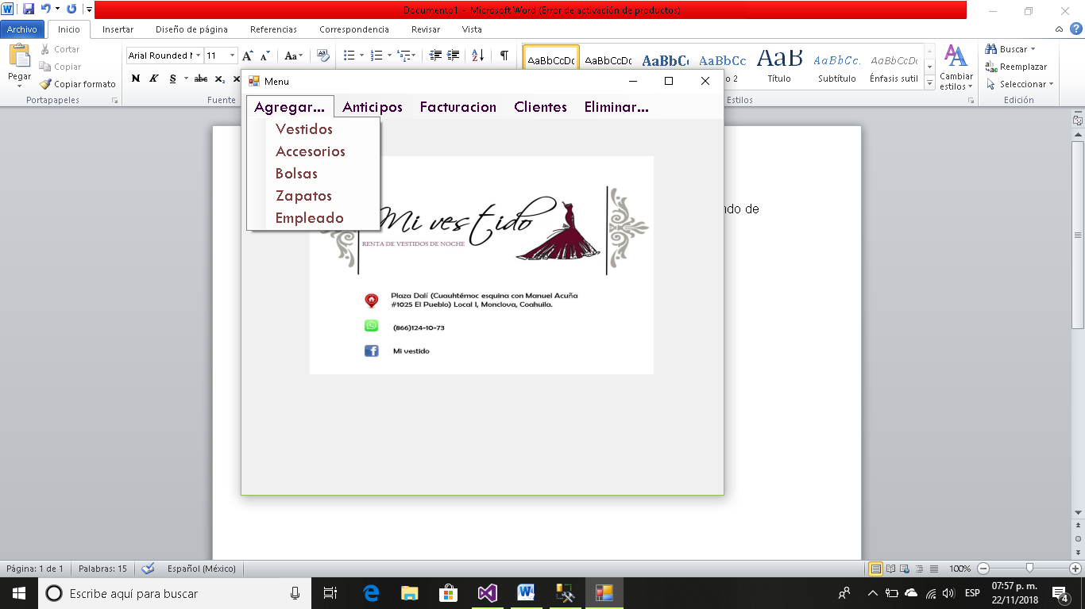

Código:

Imports System.Data.OleDb

Imports System.Data.SqlClient

Public Class Form1

Private oDataView As New DataView

Private oDataSet As New DataSet

Public dataset, dat As New DataSet

Public adapter As New OleDbDataAdapter

Public i As Integer

Private Sub LiToolStripMenuItem_Click(sender As Object, e As EventArgs) Handles LiToolStripMenuItem.Click

Liquidacion.Show()

End Sub

Private Sub VestidosToolStripMenuItem_Click(sender As Object, e As EventArgs) Handles VestidosToolStripMenuItem.Click

Vestidos.Show()

End Sub

Private Sub AccesoriosToolStripMenuItem_Click(sender As Object, e As EventArgs) Handles AccesoriosToolStripMenuItem.Click

Accesorios.Show()

End Sub

Private Sub BolsasToolStripMenuItem_Click(sender As Object, e As EventArgs) Handles BolsasToolStripMenuItem.Click

Bolsas.Show()

End Sub

Private Sub ZapatosToolStripMenuItem_Click(sender As Object, e As EventArgs) Handles ZapatosToolStripMenuItem.Click

Zapatos.Show()

End Sub

Private Sub EmpleadoToolStripMenuItem_Click(sender As Object, e As EventArgs) Handles EmpleadoToolStripMenuItem.Click

Empleados.Show()

End Sub

Private Sub RegistrarToolStripMenuItem_Click(sender As Object, e As EventArgs) Handles RegistrarToolStripMenuItem.Click

RegistrodeAnticipos.Show()

End Sub

Private Sub ConsultarToolStripMenuItem_Click(sender As Object, e As EventArgs) Handles ConsultarToolStripMenuItem.Click

DataGridView1.Visible = True

Label1.Visible = True

TextBox1.Visible = True

Button1.Visible = True

Button2.Visible = True

PictureBox1.Visible = False

End Sub

Private Sub Button2_Click(sender As Object, e As EventArgs) Handles Button2.Click

Dim oConexion As New SqlConnection()

oConexion.ConnectionString = "Data Source=ANDREA\SQLEXPRESS;" & "Initial Catalog=MiVestido; Integrated Security=True;" & "MultipleActiveResultSets = True"

oDataSet = New DataSet()

Dim oDataAdapter As SqlDataAdapter

Query = "select Anticipo from Anticipos where Semana='" + TextBox1.Text + "'"

oDataAdapter = New SqlDataAdapter(Query, oConexion)

oDataAdapter.Fill(oDataSet, "Datos")

oDataAdapter = Nothing

oDataView.Table = oDataSet.Tables(0)

DataGridView1.DataSource = oDataView

oConexion.Close()

End Sub

Private Sub Button1_Click(sender As Object, e As EventArgs) Handles Button1.Click

DataGridView1.DataSource = Nothing

TextBox1.Clear()

TextBox2.Clear()

DataGridView1.Visible = False

Label1.Visible = False

TextBox1.Visible = False

Button1.Visible = False

Button2.Visible = False

PictureBox1.Visible = True

Label2.Visible = False

Button3.Visible = False

Label3.Visible = False

TextBox2.Visible = False

Button4.Visible = False

End Sub

Private Sub MostrarClientesToolStripMenuItem_Click(sender As Object, e As EventArgs) Handles MostrarClientesToolStripMenuItem.Click

DataGridView1.Visible = True

Button1.Visible = True

PictureBox1.Visible = False

abrir()

oDataSet = New DataSet()

Dim oDataAdapter As SqlDataAdapter

Query = "select * from Clientes"

oDataAdapter = New SqlDataAdapter(Query, cnn)

oDataAdapter.Fill(oDataSet, "Datos")

oDataAdapter = Nothing

oDataView.Table = oDataSet.Tables(0)

DataGridView1.DataSource = oDataView

End Sub

Private Sub ClientesConMasRentasToolStripMenuItem_Click(sender As Object, e As EventArgs) Handles ClientesConMasRentasToolStripMenuItem.Click

DataGridView1.Visible = True

Button1.Visible = True

PictureBox1.Visible = False

abrir()

oDataSet = New DataSet()

Dim oDataAdapter As SqlDataAdapter

Query = "select top 10 C.Nom_Cl , COUNT(A.Id_Cl)as NumeroDeRentas from Clientes as C, Anticipos as A where C.Id_Cl=A.Id_Cl group by C.Nom_Cl"

oDataAdapter = New SqlDataAdapter(Query, cnn)

oDataAdapter.Fill(oDataSet, "Datos")

oDataAdapter = Nothing

oDataView.Table = oDataSet.Tables(0)

DataGridView1.DataSource = oDataView

End Sub

Private Sub ConsultarRentasToolStripMenuItem_Click(sender As Object, e As EventArgs) Handles ConsultarRentasToolStripMenuItem.Click

TextBox1.Visible = True

DataGridView1.Visible = True

Button1.Visible = True

Button3.Visible = True

PictureBox1.Visible = False

Label2.Visible = True

End Sub

Private Sub Button3_Click(sender As Object, e As EventArgs) Handles Button3.Click

abrir()

oDataSet = New DataSet()

Dim oDataAdapter As SqlDataAdapter

Query = "select * from Anticipos where Fecha_Rent='" + TextBox1.Text + "'"

oDataAdapter = New SqlDataAdapter(Query, cnn)

oDataAdapter.Fill(oDataSet, "Datos")

oDataAdapter = Nothing

oDataView.Table = oDataSet.Tables(0)

DataGridView1.DataSource = oDataView

End Sub

Private Sub VestidoToolStripMenuItem_Click(sender As Object, e As EventArgs) Handles VestidoToolStripMenuItem.Click

Label3.Visible = True

TextBox2.Visible = True

Button4.Visible = True

Button1.Visible = True

PictureBox1.Visible = False

i = 1

End Sub

Private Sub AccesorioToolStripMenuItem_Click(sender As Object, e As EventArgs) Handles AccesorioToolStripMenuItem.Click

Label3.Visible = True

TextBox2.Visible = True

Button4.Visible = True

Button1.Visible = True

PictureBox1.Visible = False

i = 2

End Sub

Private Sub BolsaToolStripMenuItem_Click(sender As Object, e As EventArgs) Handles BolsaToolStripMenuItem.Click

Label3.Visible = True

TextBox2.Visible = True

Button4.Visible = True

Button1.Visible = True

PictureBox1.Visible = False

i = 3

End Sub

Private Sub ZapatosToolStripMenuItem1_Click(sender As Object, e As EventArgs) Handles ZapatosToolStripMenuItem1.Click

Label3.Visible = True

TextBox2.Visible = True

Button4.Visible = True

Button1.Visible = True

PictureBox1.Visible = False

i = 4

End Sub

Private Sub EmpleadoToolStripMenuItem1_Click(sender As Object, e As EventArgs) Handles EmpleadoToolStripMenuItem1.Click

Label3.Visible = True

TextBox2.Visible = True

Button4.Visible = True

Button1.Visible = True

PictureBox1.Visible = False

i = 5

End Sub

Private Sub Button4_Click(sender As Object, e As EventArgs) Handles Button4.Click

abrir()

If i = 1 Then

Query = "delete from Vestidos where Id_Vest='" + TextBox2.Text + "'"

cmd = New SqlClient.SqlCommand(Query, cnn)

cmd.ExecuteNonQuery()

cnn.Close()

MsgBox("ELIMINADO")

End If

If i = 2 Then

Query = "delete from Accesorios where Id_Acc='" + TextBox2.Text + "'"

cmd = New SqlClient.SqlCommand(Query, cnn)

cmd.ExecuteNonQuery()

cnn.Close()

MsgBox("ELIMINADO")

End If

If i = 3 Then

Query = "delete from Bolsas where Id_Bolsa='" + TextBox2.Text + "'"

cmd = New SqlClient.SqlCommand(Query, cnn)

cmd.ExecuteNonQuery()

cnn.Close()

MsgBox("ELIMINADO")

End If

If i = 4 Then

Query = "delete from Zapatos where Id_Zap='" + TextBox2.Text + "'"

cmd = New SqlClient.SqlCommand(Query, cnn)

cmd.ExecuteNonQuery()

cnn.Close()

MsgBox("ELIMINADO")

End If

If i = 5 Then

Query = "delete from Empleados where Id_Emp='" + TextBox2.Text + "'"

cmd = New SqlClient.SqlCommand(Query, cnn)

cmd.ExecuteNonQuery()

cnn.Close()

MsgBox("ELIMINADO")

End If

End Sub

Private Sub CorteSemanalToolStripMenuItem_Click(sender As Object, e As EventArgs) Handles CorteSemanalToolStripMenuItem.Click

CorteSemanal.Show()

End Sub

Private Sub PagoEmpleadosToolStripMenuItem_Click(sender As Object, e As EventArgs) Handles PagoEmpleadosToolStripMenuItem.Click

PagoEmpleados.Show()

End Sub

**Pantalla para agregar Vestidos.**

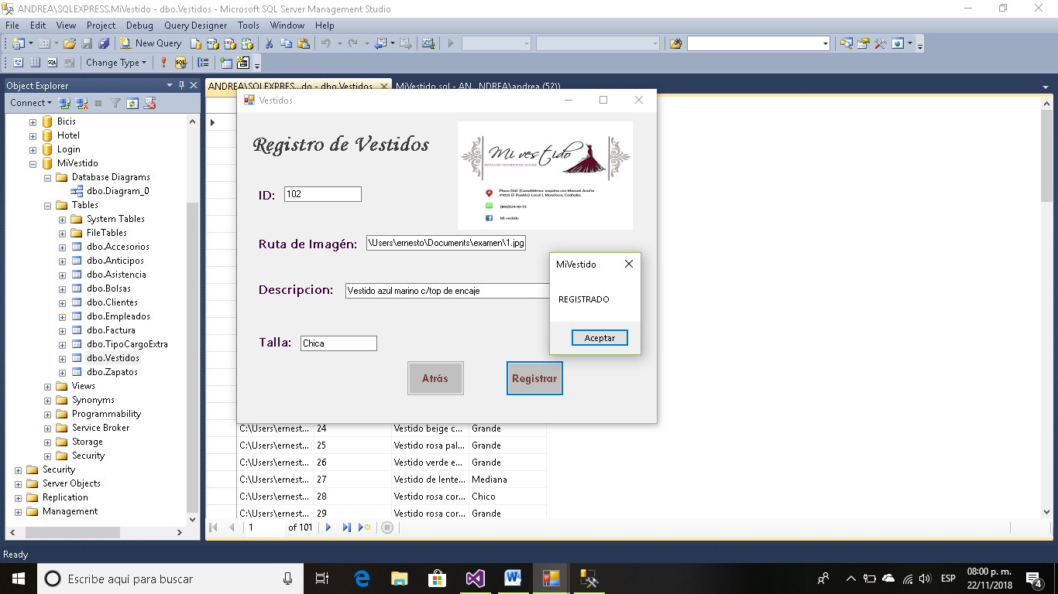

Código:

Public Class Vestidos

Private Sub Vestidos_Load(sender As Object, e As EventArgs) Handles MyBase.Load

abrir()

End Sub

Private Sub Button2_Click(sender As Object, e As EventArgs) Handles Button2.Click

Query = "insert into Vestidos values ( '" + TextBox1.Text + "','" + TextBox2.Text + "','" + TextBox3.Text + "','" + TextBox4.Text + "')"

cmd = New SqlClient.SqlCommand(Query, cnn)

cmd.ExecuteNonQuery()

cnn.Close()

MsgBox("REGISTRADO")

End Sub

Private Sub Button1_Click(sender As Object, e As EventArgs) Handles Button1.Click

Form1.Show()

Me.Close()

End Sub

End Class

**Pantalla para agregar Accesorios.**

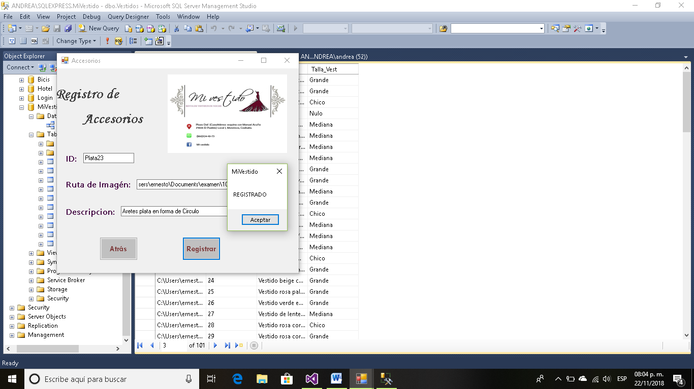

Código:

Public Class Accesorios

Private Sub Button2_Click(sender As Object, e As EventArgs) Handles Button2.Click

Query = "insert into Accesorios values ( '" + TextBox2.Text + "','" + TextBox1.Text + "','" + TextBox3.Text + "')"

cmd = New SqlClient.SqlCommand(Query, cnn)

cmd.ExecuteNonQuery()

cnn.Close()

MsgBox("REGISTRADO")

End Sub

Private Sub Button1_Click(sender As Object, e As EventArgs) Handles Button1.Click

Form1.Show()

Me.Close()

End Sub

Private Sub Accesorios_Load(sender As Object, e As EventArgs) Handles MyBase.Load

abrir()

End Sub

End Class

**Pantalla para agregar Bolsas.**

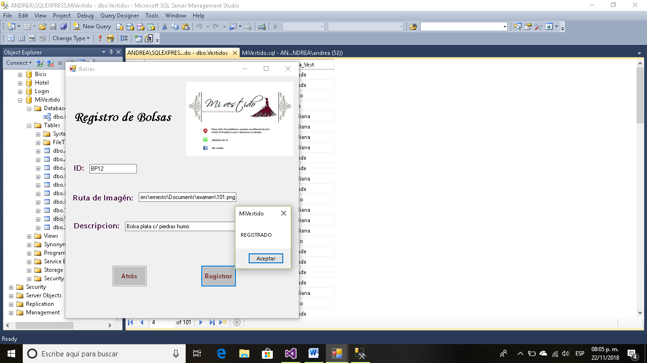

Código:

Public Class Bolsas

Private Sub Button2_Click(sender As Object, e As EventArgs) Handles Button2.Click

Query = "insert into Bolsas values ( '" + TextBox2.Text + "','" + TextBox1.Text + "','" + TextBox3.Text + "')"

cmd = New SqlClient.SqlCommand(Query, cnn)

cmd.ExecuteNonQuery()

cnn.Close()

MsgBox("REGISTRADO")

End Sub

Private Sub Button1_Click(sender As Object, e As EventArgs) Handles Button1.Click

Form1.Show()

Me.Close()

End Sub

Private Sub Bolsas_Load(sender As Object, e As EventArgs) Handles MyBase.Load

abrir()

End Sub

End Class

**Pantalla para agregar Zapatos.**

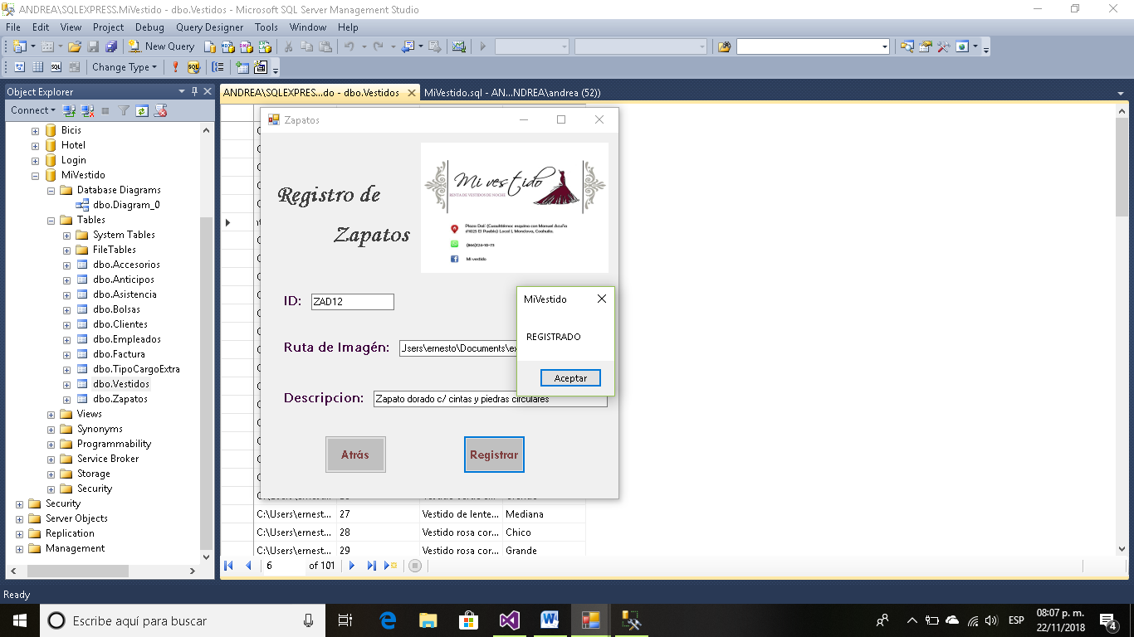

Código:

Public Class Zapatos

Private Sub Button2_Click(sender As Object, e As EventArgs) Handles Button2.Click

Query = "insert into Zapatos values ( '" + TextBox2.Text + "','" + TextBox1.Text + "','" + TextBox3.Text + "')"

cmd = New SqlClient.SqlCommand(Query, cnn)

cmd.ExecuteNonQuery()

cnn.Close()

MsgBox("REGISTRADO")

End Sub

Private Sub Button1_Click(sender As Object, e As EventArgs) Handles Button1.Click

Form1.Show()

Me.Close()

End Sub

Private Sub Zapatos_Load(sender As Object, e As EventArgs) Handles MyBase.Load

abrir()

End Sub

End Class

**Pantalla para agregar Empleados.**

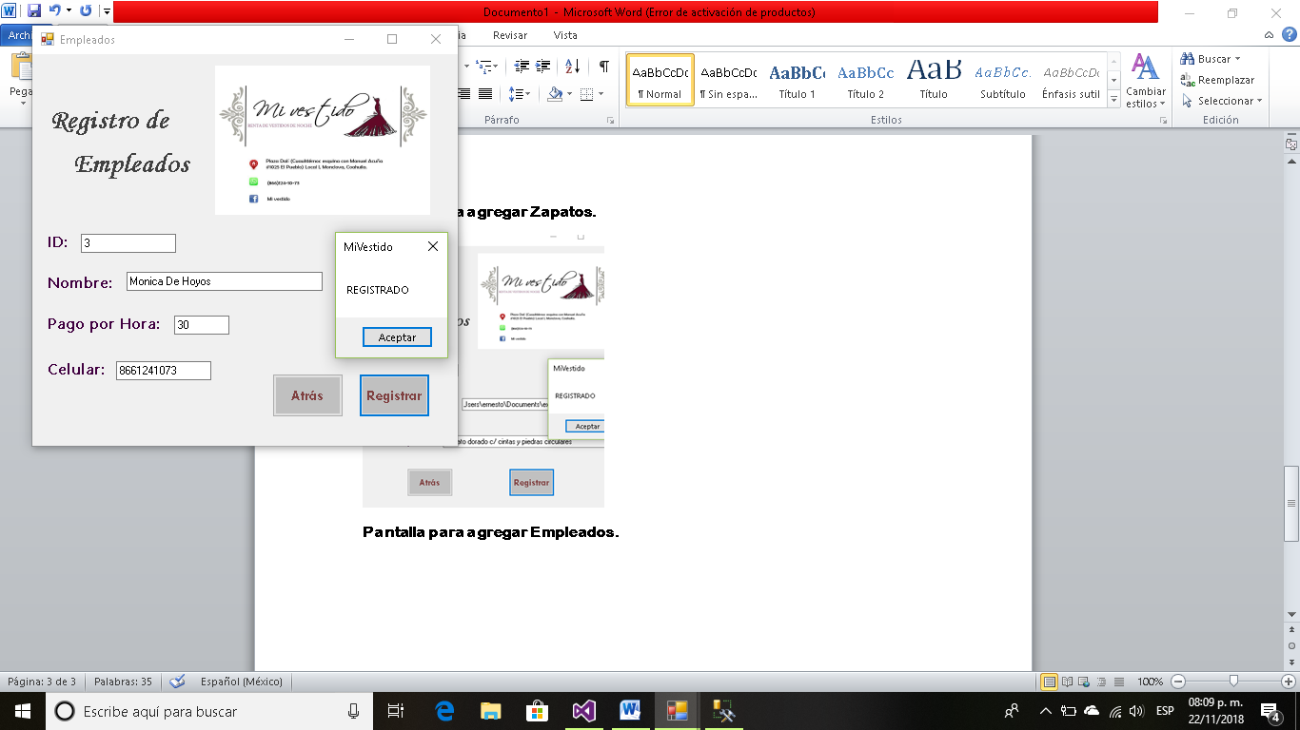

Código:

Public Class Empleados

Private Sub Button2_Click(sender As Object, e As EventArgs) Handles Button2.Click

Query = "insert into Empleados values ( '" + TextBox1.Text + "','" + TextBox2.Text + "','" + TextBox3.Text + "','" + TextBox4.Text + "')"

cmd = New SqlClient.SqlCommand(Query, cnn)

cmd.ExecuteNonQuery()

cnn.Close()

MsgBox("REGISTRADO")

End Sub

Private Sub Button1_Click(sender As Object, e As EventArgs) Handles Button1.Click

Form1.Show()

Me.Close()

End Sub

Private Sub Empleados_Load(sender As Object, e As EventArgs) Handles MyBase.Load

abrir()

End Sub

End Class

**Opciones de Anticipo.**

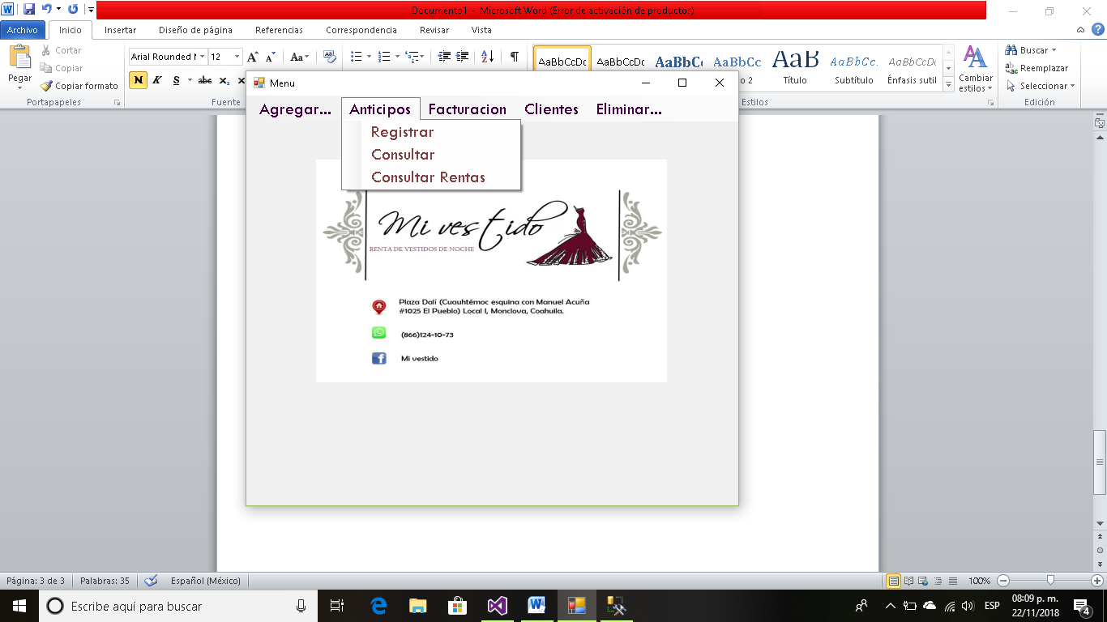

**Pantalla Registrar Anticipo.** Como vemos tenemos campos que se llenan haciendo búsquedas enseguida mostraré cada una de esas búsquedas.

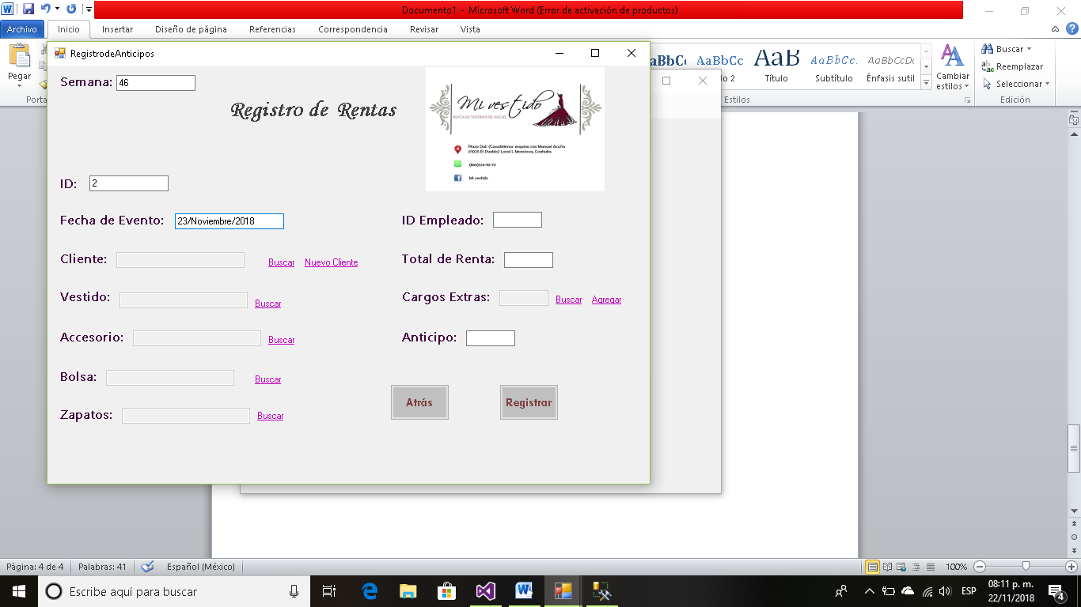

Código:

Public Class RegistrodeAnticipos

Private Sub Button2_Click(sender As Object, e As EventArgs) Handles Button2.Click

Query = "insert into Anticipos values ( '" + TextBox4.Text + "','" + TextBox1.Text + "','" + TextBox2.Text + "','" + TextBox3.Text + "','" + TextBox5.Text + "','" + TextBox6.Text + "','" + TextBox7.Text + "','" + TextBox8.Text + "','" + TextBox9.Text + "','" + TextBox10.Text + "','" + TextBox11.Text + "','" + TextBox12.Text + "')"

cmd = New SqlClient.SqlCommand(Query, cnn)

cmd.ExecuteNonQuery()

cnn.Close()

MsgBox("REGISTRADO")

End Sub

Private Sub RegistrodeAnticipos_Load(sender As Object, e As EventArgs) Handles MyBase.Load

abrir()

End Sub

Private Sub Button1_Click(sender As Object, e As EventArgs) Handles Button1.Click

Form1.Show()

Me.Close()

End Sub

Private Sub LinkLabel1_LinkClicked(sender As Object, e As LinkLabelLinkClickedEventArgs) Handles LinkLabel1.LinkClicked

BusquedadeItems.Show()

End Sub

Private Sub LinkLabel2_LinkClicked(sender As Object, e As LinkLabelLinkClickedEventArgs) Handles LinkLabel2.LinkClicked

RegistrodeClientes.Show()

End Sub

Private Sub LinkLabel3_LinkClicked(sender As Object, e As LinkLabelLinkClickedEventArgs) Handles LinkLabel3.LinkClicked

BusquedadeVestido.Show()

End Sub

Private Sub LinkLabel4_LinkClicked(sender As Object, e As LinkLabelLinkClickedEventArgs) Handles LinkLabel4.LinkClicked

BusquedaAccesorio.Show()

End Sub

Private Sub LinkLabel5_LinkClicked(sender As Object, e As LinkLabelLinkClickedEventArgs) Handles LinkLabel5.LinkClicked

BusquedaBolsas.Show()

End Sub

Private Sub LinkLabel6_LinkClicked(sender As Object, e As LinkLabelLinkClickedEventArgs) Handles LinkLabel6.LinkClicked

BusquedaZapatos.Show()

End Sub

Private Sub LinkLabel7_LinkClicked(sender As Object, e As LinkLabelLinkClickedEventArgs) Handles LinkLabel7.LinkClicked

BusquedaCargos.Show()

End Sub

Private Sub LinkLabel8_LinkClicked(sender As Object, e As LinkLabelLinkClickedEventArgs) Handles LinkLabel8.LinkClicked

AgregarCargoExtra.Show()

End Sub

End Class

**Búsqueda de Cliente.**

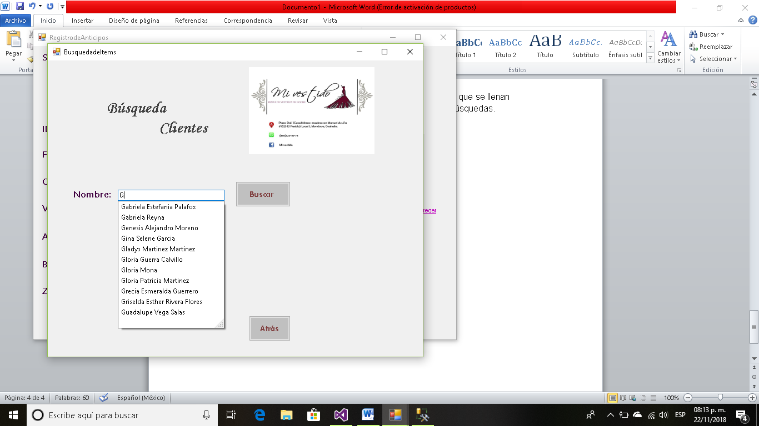

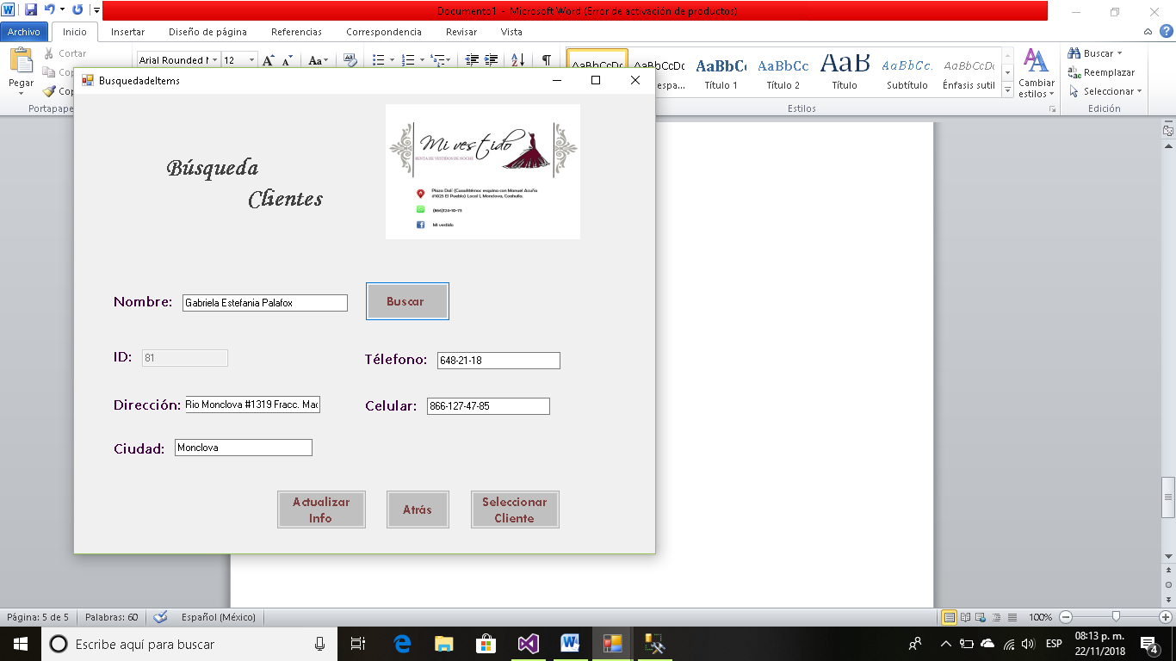

También podemos actualizar la información ya sea que el cliente cambio de teléfono o dirección, o cualquier dato. Excepto el ID obviamente.

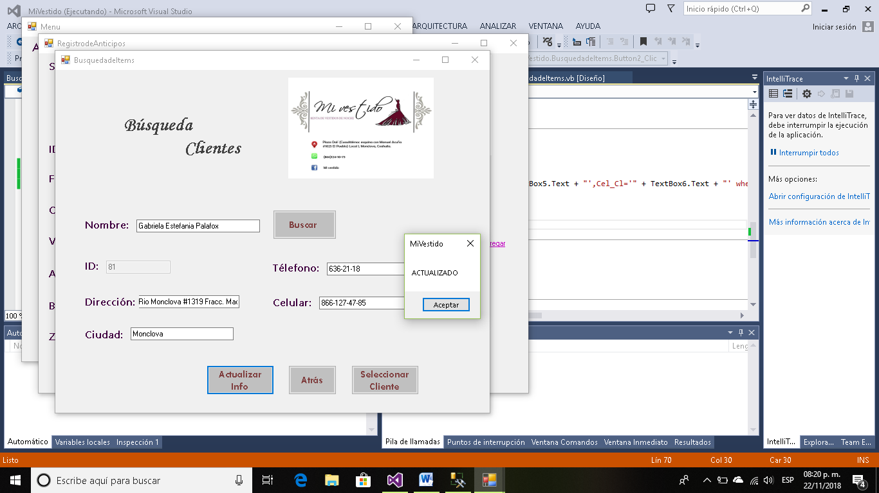

Código:

Imports System.Data.Sql

Imports System.Data.SqlClient

Public Class BusquedadeItems

Dim nombre As String

Public Id As String

Private Sub BusquedadeItems_Load(sender As Object, e As EventArgs) Handles MyBase.Load

abrir()

Autocompletar(TextBox2)

End Sub

Private Sub Button3_Click(sender As Object, e As EventArgs) Handles Button3.Click

Dim Direccion As String

Dim Ciudad As String

Dim Telefono As String

Dim Celular As String

nombre = TextBox2.Text

Label4.Visible = True

Label5.Visible = True

Label6.Visible = True

Label7.Visible = True

Label8.Visible = True

TextBox1.Visible = True

TextBox3.Visible = True

TextBox4.Visible = True

TextBox5.Visible = True

TextBox6.Visible = True

Button2.Visible = True

Button4.Visible = True

Query = "select Id_Cl,Dir_Cl,Cd_Cl,Tel_Cl,Cel_Cl from Clientes where Nom_Cl='" & nombre & "'"

cmd = New SqlClient.SqlCommand(Query, cnn)

cmd.ExecuteNonQuery()

Dim reader As SqlDataReader = cmd.ExecuteReader

reader.Read()

Id = reader(0)

Direccion = reader(1)

Ciudad = reader(2)

Telefono = reader(3)

Celular = reader(4)

TextBox1.Text = Id

TextBox3.Text = Direccion

TextBox4.Text = Ciudad

TextBox5.Text = Telefono

TextBox6.Text = Celular

End Sub

Private Sub Button2_Click_1(sender As Object, e As EventArgs) Handles Button2.Click

reconectar()

Query = "update Clientes set Dir_Cl='" + TextBox3.Text + "',Cd_Cl='" + TextBox4.Text + "',Tel_Cl='" + TextBox5.Text + "',Cel_Cl='" + TextBox6.Text + "' where Nom_Cl ='" + TextBox2.Text + "'"

cmd = New SqlClient.SqlCommand(Query, cnn)

cmd.ExecuteNonQuery()

cnn.Close()

MsgBox("ACTUALIZADO")

End Sub

Private Sub Button1_Click(sender As Object, e As EventArgs) Handles Button1.Click

RegistrodeAnticipos.Show()

Me.Close()

End Sub

Private Sub Button4_Click(sender As Object, e As EventArgs) Handles Button4.Click

RegistrodeAnticipos.TextBox2.Text = Id

RegistrodeAnticipos.Show()

Me.Close()

End Sub

End Class

Al usar el botón seleccionar automáticamente nos los agrega al registro de Anticipo.

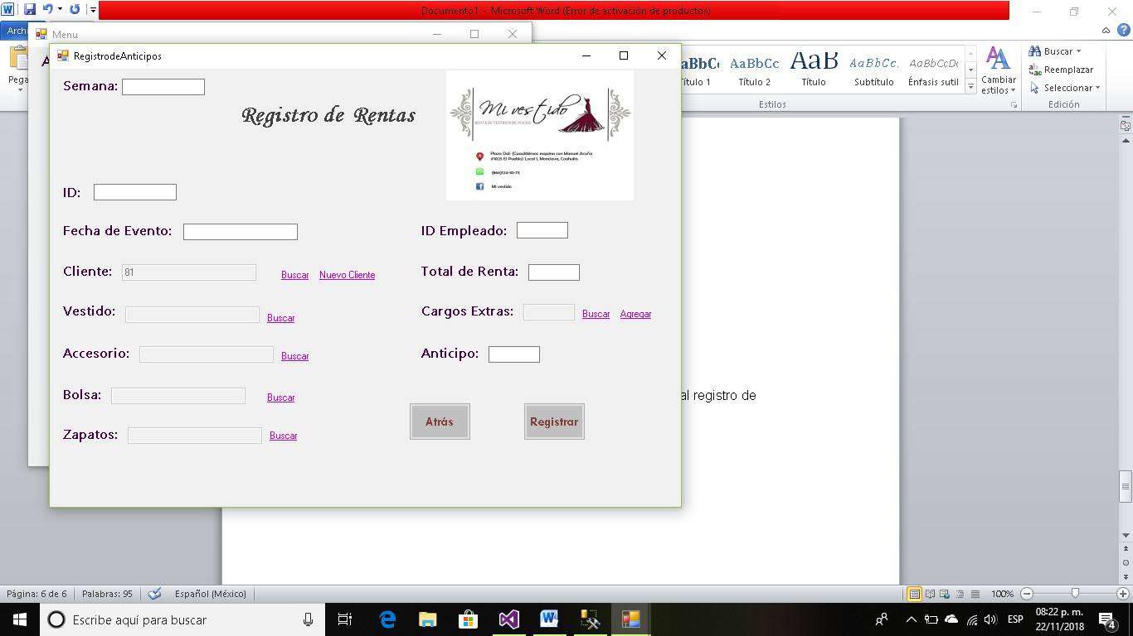

También tenemos la opción de agregar un nuevo cliente.

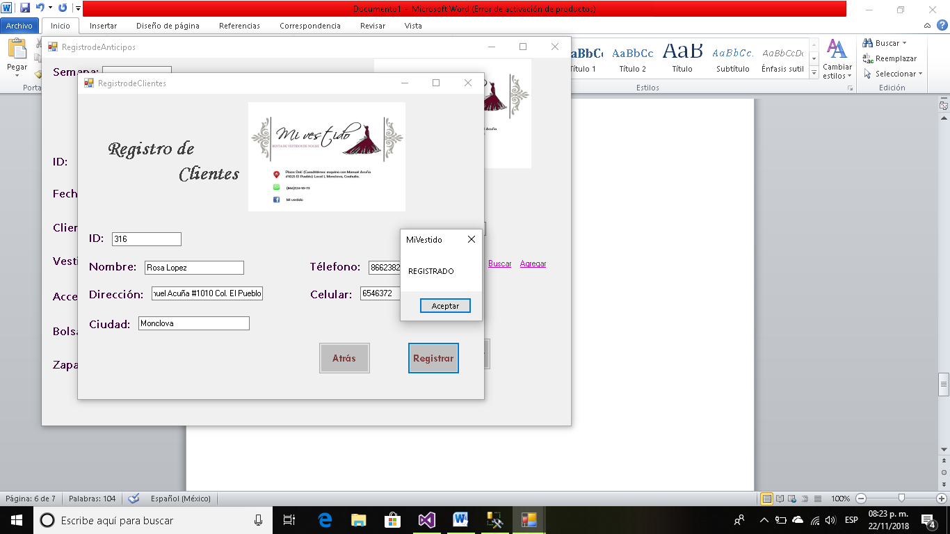

Código:

Public Class RegistrodeClientes

Private Sub Button2_Click(sender As Object, e As EventArgs) Handles Button2.Click

Query = "insert into Clientes values ( '" + TextBox1.Text + "','" + TextBox2.Text + "','" + TextBox3.Text + "','" + TextBox4.Text + "','" + TextBox5.Text + "','" + TextBox6.Text + "')"

cmd = New SqlClient.SqlCommand(Query, cnn)

cmd.ExecuteNonQuery()

cnn.Close()

MsgBox("REGISTRADO")

End Sub

Private Sub RegistrodeClientes_Load(sender As Object, e As EventArgs) Handles MyBase.Load

abrir()

End Sub

Private Sub Button1_Click(sender As Object, e As EventArgs) Handles Button1.Click

RegistrodeAnticipos.Show()

Me.Close()

End Sub

End Class

Y es igual con cada campo tenemos la ventana de búsqueda.

**Búsqueda de Vestido.**

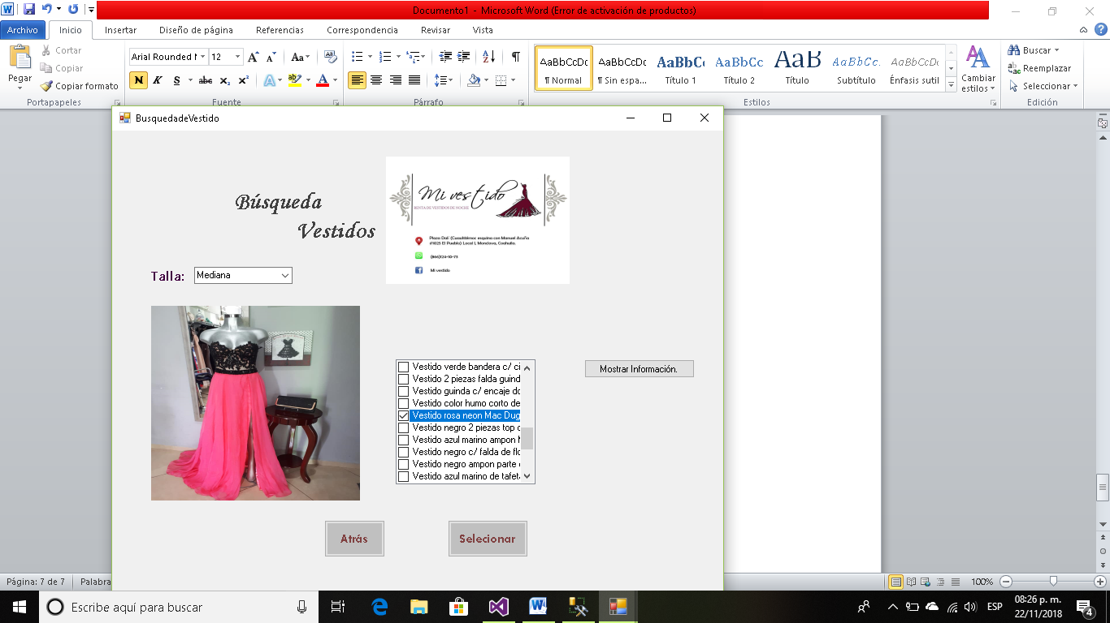

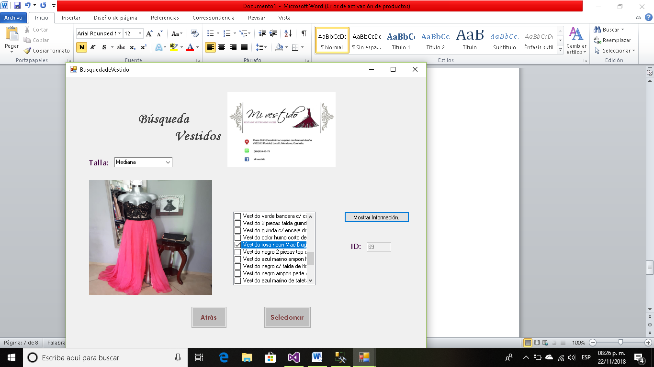

Código:

Imports System.Data.Sql

Imports System.Data.SqlClient

Public Class BusquedadeVestido

Public idvestido As String

Private Sub BusquedadeVestido_Load(sender As Object, e As EventArgs) Handles MyBase.Load

abrir()

If Tallas() > 0 Then

cargarTallas(ComboBox1)

ComboBox1.SelectedIndex = 0

Else

MsgBox("No Tallas")

End If

End Sub

Private Sub CheckedListBox1_SelectedIndexChanged(sender As Object, e As EventArgs) Handles CheckedListBox1.SelectedIndexChanged

Dim ruta As String = consultaRutaVestido(CheckedListBox1.SelectedItem.ToString)

PictureBox2.Load(ruta)

End Sub

Private Sub ComboBox1_SelectedIndexChanged(sender As Object, e As EventArgs) Handles ComboBox1.SelectedIndexChanged

If cantidadImagenesVestidos() > 0 Then

cargarImagenesVestidos(CheckedListBox1)

Else

MsgBox("No Imagenes")

End If

End Sub

Private Sub Button3_Click(sender As Object, e As EventArgs) Handles Button3.Click

Dim descripcion As String

Dim talla As String

descripcion = CheckedListBox1.SelectedItem.ToString

talla = ComboBox1.SelectedItem.ToString

Label5.Visible = True

TextBox2.Visible = True

Query = "select Id_Vest from Vestidos where Descr_Vest='" & descripcion & "'"

cmd = New SqlClient.SqlCommand(Query, cnn)

cmd.ExecuteNonQuery()

Dim reader As SqlDataReader = cmd.ExecuteReader

reader.Read()

idvestido = reader(0)

TextBox2.Text = idvestido

End Sub

Private Sub Button1_Click(sender As Object, e As EventArgs) Handles Button1.Click

RegistrodeAnticipos.Show()

Me.Close()

End Sub

Private Sub Button2_Click(sender As Object, e As EventArgs) Handles Button2.Click

RegistrodeAnticipos.TextBox3.Text = idvestido

RegistrodeAnticipos.Show()

Me.Close()

End Sub

End Class

**Búsqueda de Accesorios.**

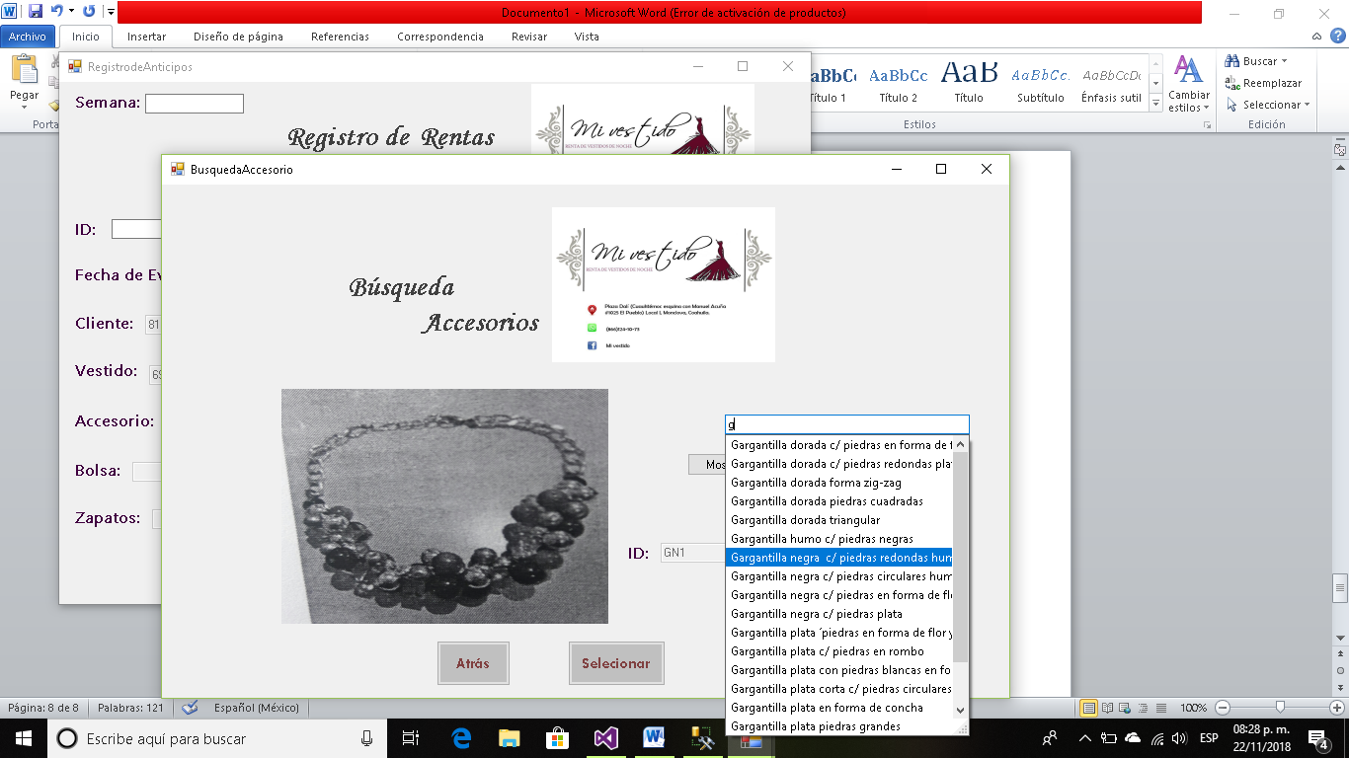

Código:

Imports System.Data.Sql

Imports System.Data.SqlClient

Public Class BusquedaAccesorio

Public idacc As String

Private Sub BusquedaAccesorio_Load(sender As Object, e As EventArgs) Handles MyBase.Load

abrir()

AutocompletarAccesorio(TextBox2)

End Sub

Private Sub Button3_Click(sender As Object, e As EventArgs) Handles Button3.Click

Dim ruta As String = consultaRutaAccesorio(TextBox2.Text)

PictureBox2.Load(ruta)

Dim descripcion As String

descripcion = TextBox2.Text

Label4.Visible = True

TextBox1.Visible = True

Button2.Visible = True

Query = "select Id_Acc from Accesorios where Descripcion_Acc='" & descripcion & "'"

cmd = New SqlClient.SqlCommand(Query, cnn)

cmd.ExecuteNonQuery()

Dim reader As SqlDataReader = cmd.ExecuteReader

reader.Read()

idacc = reader(0)

TextBox1.Text = idacc

End Sub

Private Sub Button2_Click(sender As Object, e As EventArgs) Handles Button2.Click

RegistrodeAnticipos.TextBox5.Text = idacc

RegistrodeAnticipos.Show()

Me.Close()

End Sub

Private Sub Button1_Click(sender As Object, e As EventArgs) Handles Button1.Click

RegistrodeAnticipos.Show()

Me.Close()

End Sub

End Class

**Búsqueda de Bolsa.**

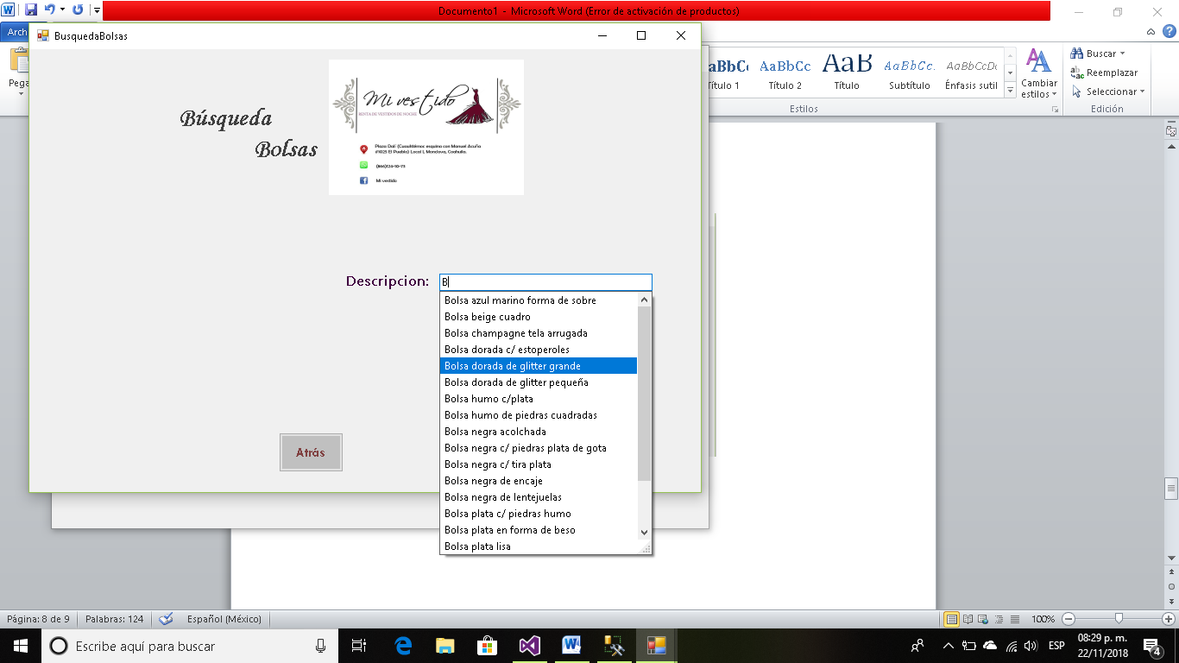

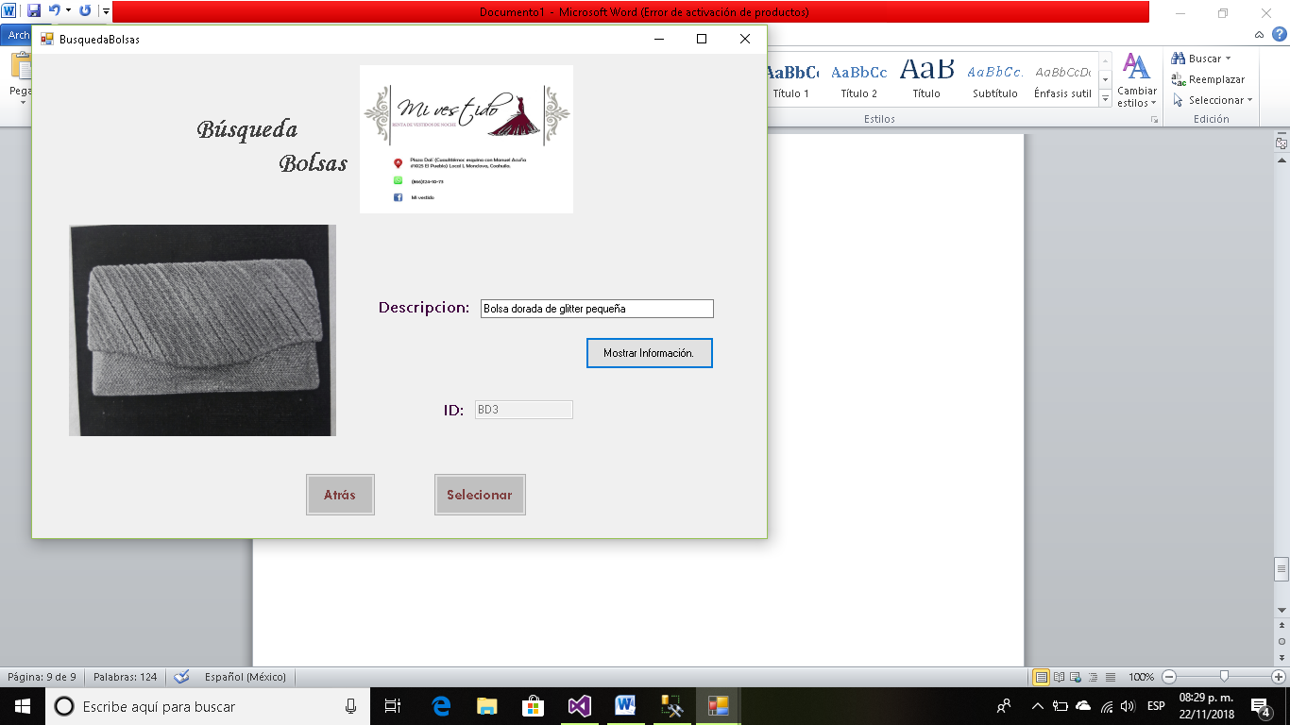

Código:

Imports System.Data.Sql

Imports System.Data.SqlClient

Public Class BusquedaBolsas

Public idbolsa As String

Private Sub Button3_Click(sender As Object, e As EventArgs) Handles Button3.Click

Dim ruta As String = consultaRutaBolsa(TextBox2.Text)

PictureBox2.Load(ruta)

Dim descripcion As String

descripcion = TextBox2.Text

Label4.Visible = True

TextBox1.Visible = True

Button2.Visible = True

Query = "select Id_Bolsa from Bolsas where Descripcion_Bolsa='" & descripcion & "'"

cmd = New SqlClient.SqlCommand(Query, cnn)

cmd.ExecuteNonQuery()

Dim reader As SqlDataReader = cmd.ExecuteReader

reader.Read()

idbolsa = reader(0)

TextBox1.Text = idbolsa

End Sub

Private Sub BusquedaBolsas_Load(sender As Object, e As EventArgs) Handles MyBase.Load

abrir()

AutocompletarBolsa(TextBox2)

End Sub

Private Sub Button2_Click(sender As Object, e As EventArgs) Handles Button2.Click

RegistrodeAnticipos.TextBox6.Text = idbolsa

RegistrodeAnticipos.Show()

Me.Close()

End Sub

Private Sub Button1_Click(sender As Object, e As EventArgs) Handles Button1.Click

RegistrodeAnticipos.Show()

Me.Close()

End Sub

End Class

**Búsqueda de Zapatos.**

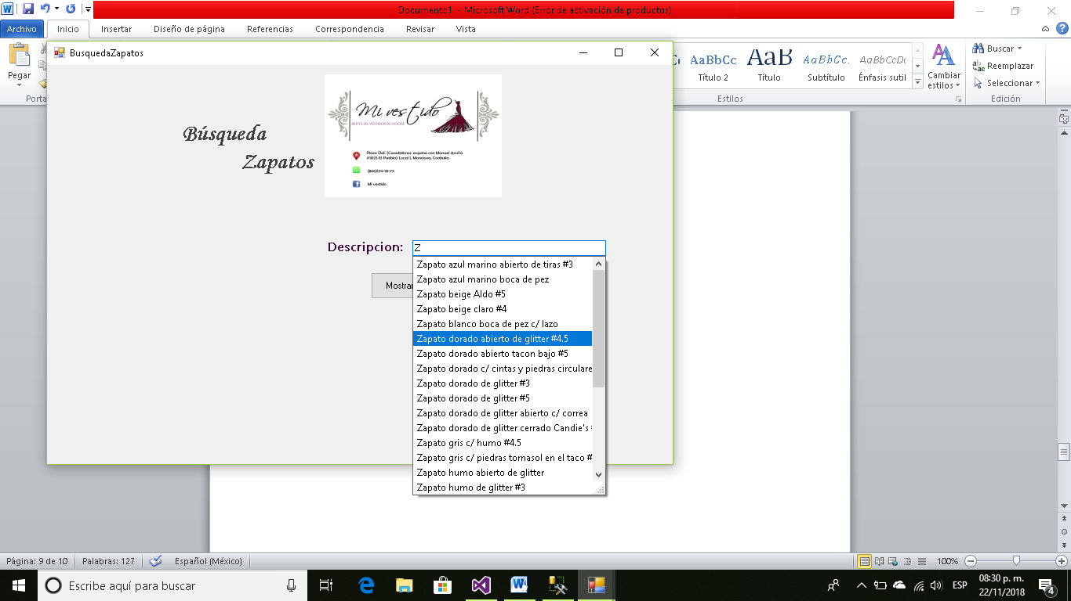

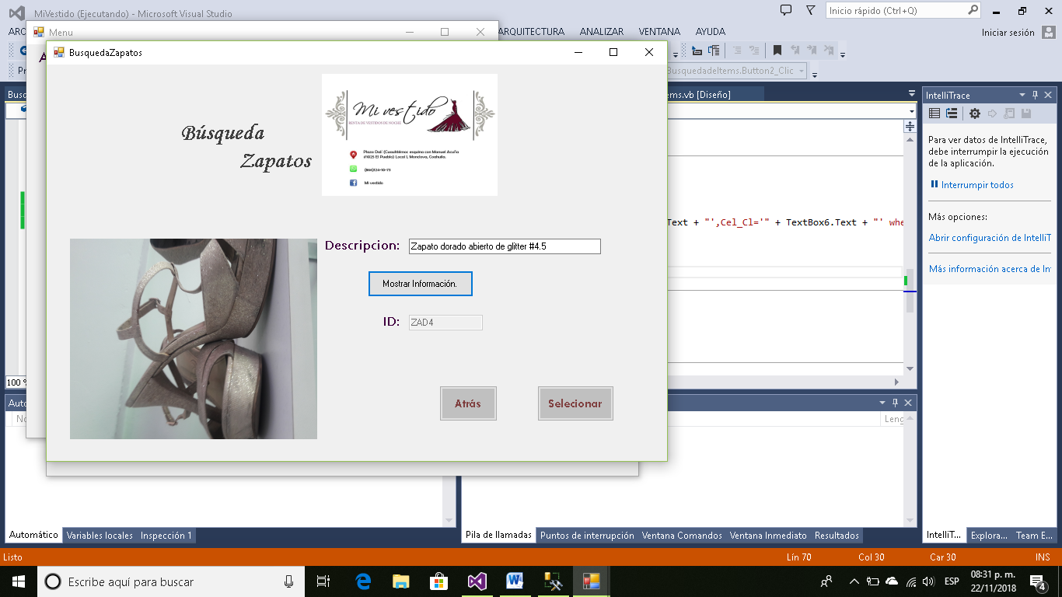

Código:

Imports System.Data.Sql

Imports System.Data.SqlClient

Public Class BusquedaZapatos

Public idzap As String

Private Sub BusquedaZapatos_Load(sender As Object, e As EventArgs) Handles MyBase.Load

abrir()

AutocompletarZapato(TextBox2)

End Sub

Private Sub Button3_Click(sender As Object, e As EventArgs) Handles Button3.Click

Dim ruta As String = consultaRutaZapato(TextBox2.Text)

PictureBox2.Load(ruta)

Dim descripcion As String

descripcion = TextBox2.Text

Label4.Visible = True

TextBox1.Visible = True

Button2.Visible = True

Query = "select Id_Zap from Zapatos where Descripcion_Zap='" & descripcion & "'"

cmd = New SqlClient.SqlCommand(Query, cnn)

cmd.ExecuteNonQuery()

Dim reader As SqlDataReader = cmd.ExecuteReader

reader.Read()

idzap = reader(0)

TextBox1.Text = idzap

End Sub

Private Sub Button2_Click(sender As Object, e As EventArgs) Handles Button2.Click

RegistrodeAnticipos.TextBox7.Text = idzap

RegistrodeAnticipos.Show()

Me.Close()

End Sub

Private Sub Button1_Click(sender As Object, e As EventArgs) Handles Button1.Click

RegistrodeAnticipos.Show()

Me.Close()

End Sub

End Class

**De igual manera podemos buscar y agregar Cargos Extras.**

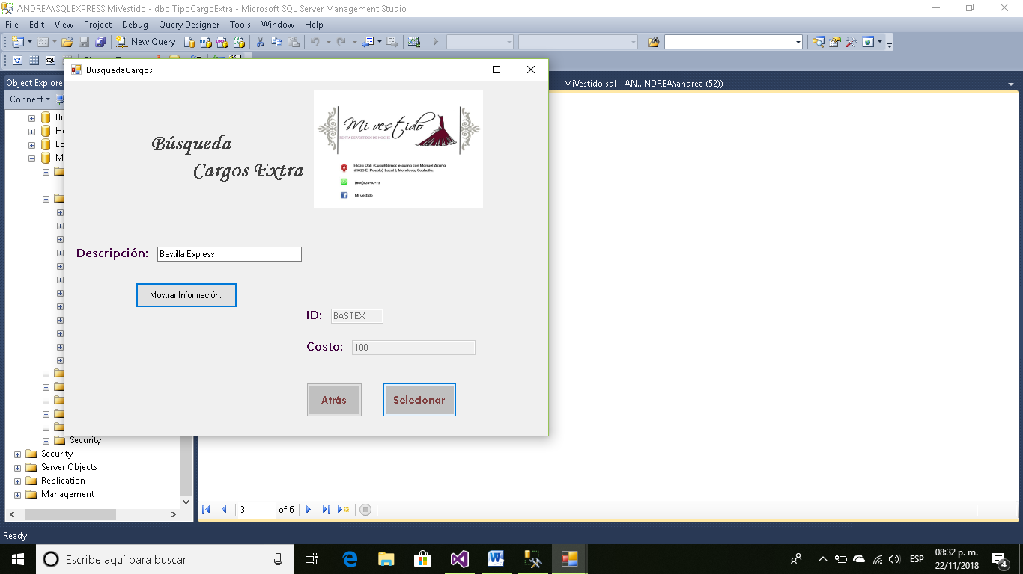

Código:

Imports System.Data.Sql

Imports System.Data.SqlClient

Public Class BusquedaCargos

Public idcargo As String

Private Sub Button3_Click(sender As Object, e As EventArgs) Handles Button3.Click

Dim descripcion As String

Dim costo As String

descripcion = TextBox2.Text

Label4.Visible = True

Label5.Visible = True

TextBox1.Visible = True

TextBox3.Visible = True

Button2.Visible = True

Query = "select Id_Cargo, Costo from TipoCargoExtra where Descripcion='" & descripcion & "'"

cmd = New SqlClient.SqlCommand(Query, cnn)

cmd.ExecuteNonQuery()

Dim reader As SqlDataReader = cmd.ExecuteReader

reader.Read()

idcargo = reader(0)

costo = reader(1)

TextBox3.Text = idcargo

TextBox1.Text = costo

End Sub

Private Sub Button1_Click(sender As Object, e As EventArgs) Handles Button1.Click

RegistrodeAnticipos.Show()

Me.Close()

End Sub

Private Sub Button2_Click(sender As Object, e As EventArgs) Handles Button2.Click

RegistrodeAnticipos.TextBox10.Text = idcargo

RegistrodeAnticipos.Show()

Me.Close()

End Sub

End Class

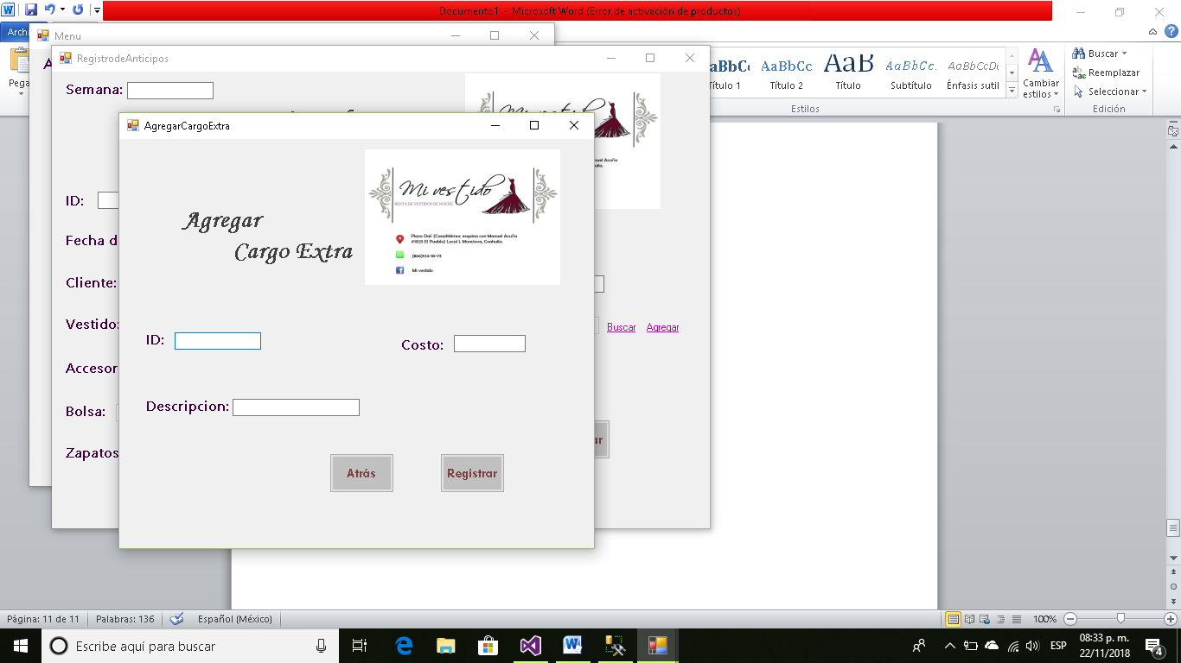

Código:

Public Class AgregarCargoExtra

Private Sub Button2_Click(sender As Object, e As EventArgs) Handles Button2.Click

Query = "insert into TipoCargoExtra values ( '" + TextBox1.Text + "','" + TextBox2.Text + "','" + TextBox3.Text + "')"

cmd = New SqlClient.SqlCommand(Query, cnn)

cmd.ExecuteNonQuery()

cnn.Close()

MsgBox("REGISTRADO")

End Sub

Private Sub Button1_Click(sender As Object, e As EventArgs) Handles Button1.Click

RegistrodeAnticipos.Show()

Me.Close()

End Sub

Private Sub AgregarCargoExtra_Load(sender As Object, e As EventArgs) Handles MyBase.Load

abrir()

End Sub

End Class

**Y al final Registramos el Anticipo en nuestra base.**

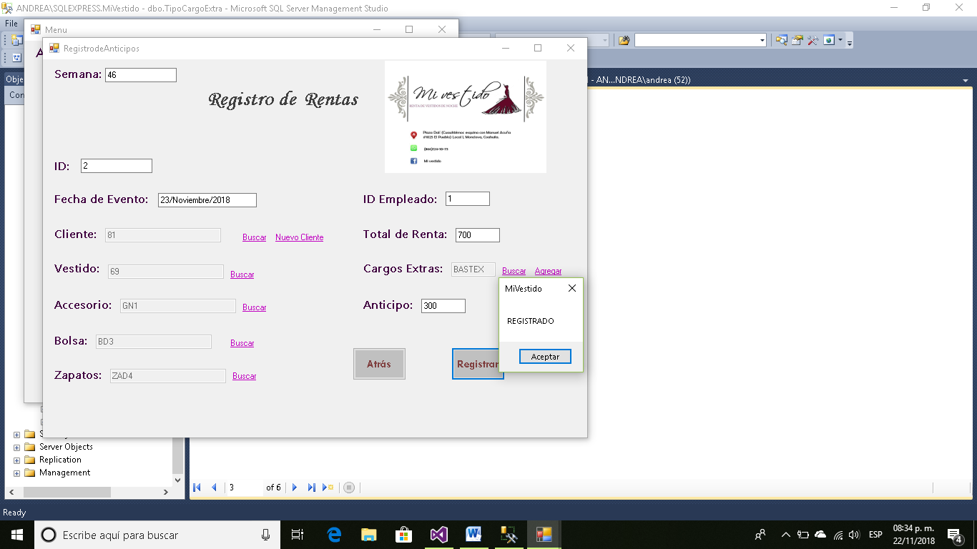

**Volvemos al Menú Principal y ahora usamos la opción de consultar Anticipos.**

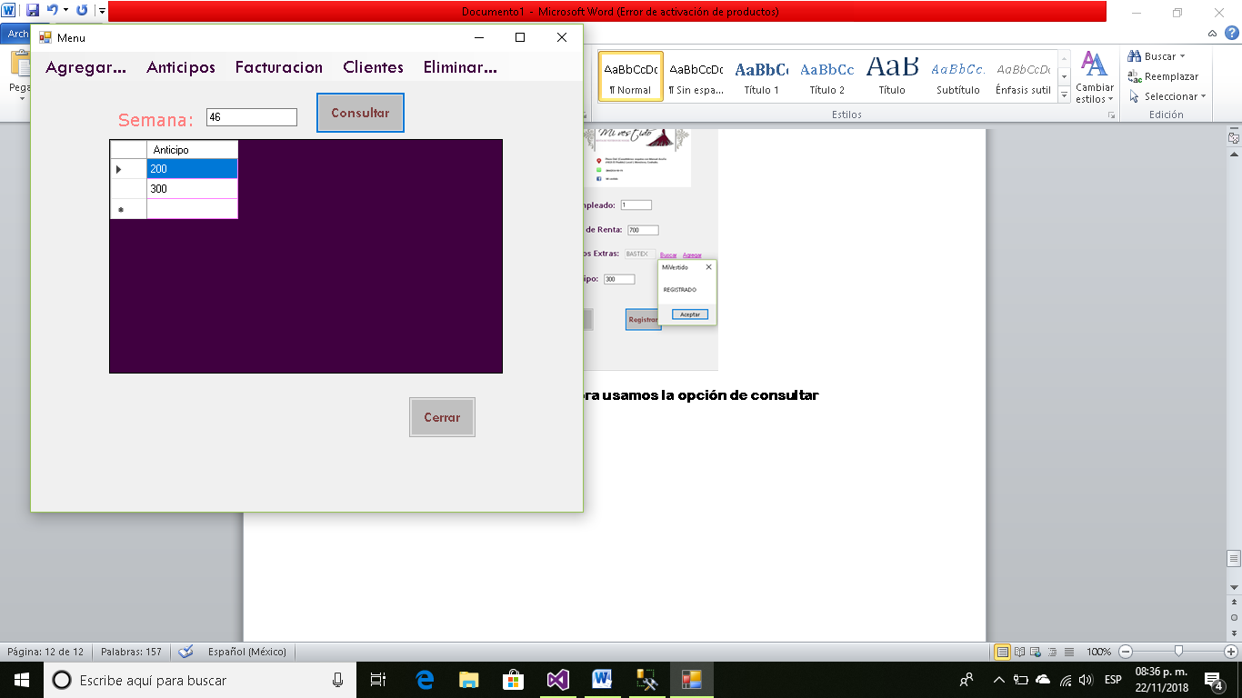

Y así podemos ver cuantos anticipos hemos tenido en la semana.

También podemos consultar las rentas que tenemos para determinada fecha.

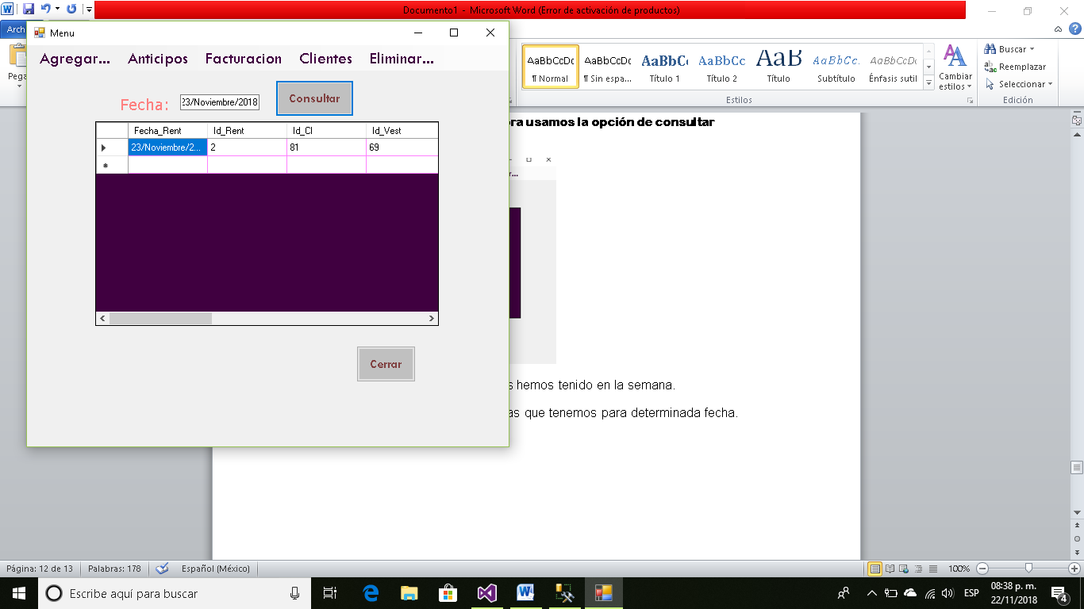

Ahora veremos las opciones de Facturación.

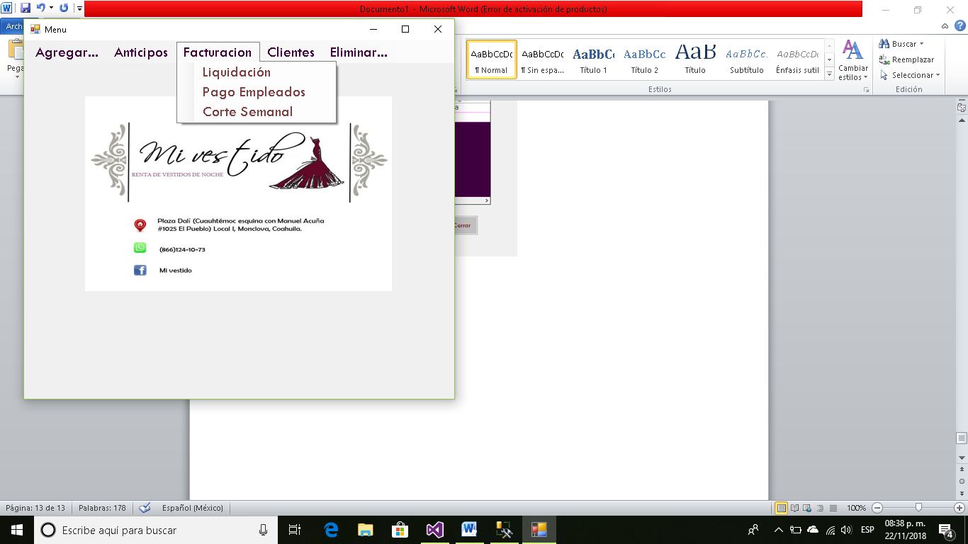

**Ventana Liquidación.**

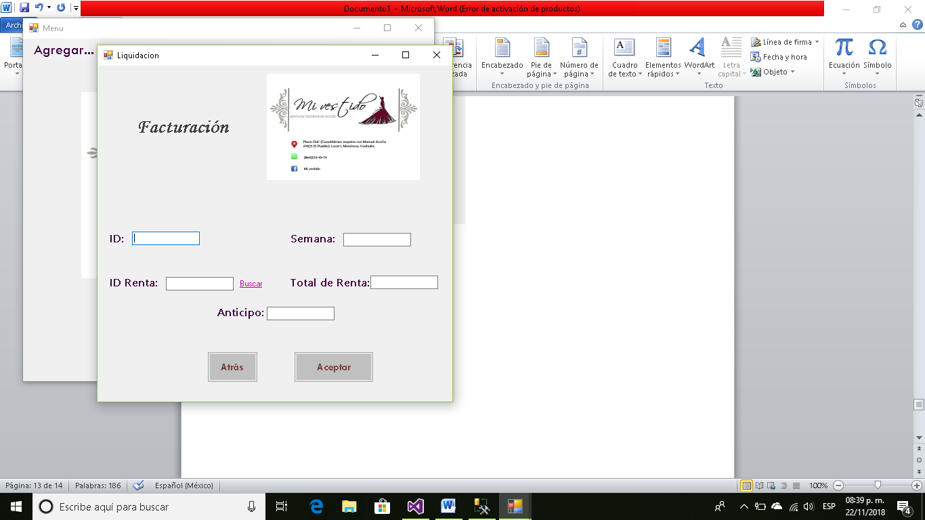

Código:

Public Class Liquidacion

Private Sub LinkLabel1_LinkClicked(sender As Object, e As LinkLabelLinkClickedEventArgs) Handles LinkLabel1.LinkClicked

BusquedaRenta.Show()

End Sub

Private Sub Button2_Click(sender As Object, e As EventArgs) Handles Button2.Click

reconectar()

Query = "insert into Factura values ( '" + TextBox1.Text + "','" + TextBox2.Text + "','" + TextBox3.Text + "','" + TextBox4.Text + "')"

cmd = New SqlClient.SqlCommand(Query, cnn)

cmd.ExecuteNonQuery()

cnn.Close()

MsgBox("REGISTRADO")

End Sub

Private Sub Liquidacion_Load(sender As Object, e As EventArgs) Handles MyBase.Load

abrir()

End Sub

Private Sub Button1_Click(sender As Object, e As EventArgs) Handles Button1.Click

Form1.Show()

Me.Close()

End Sub

End Class

Vemos que de igual manera debemos buscar la renta que queremos liquidar el cliente contará con su número de cliente y fecha de evento que es el que nosotros usaremos para saber que renta es la que debemos elegir.

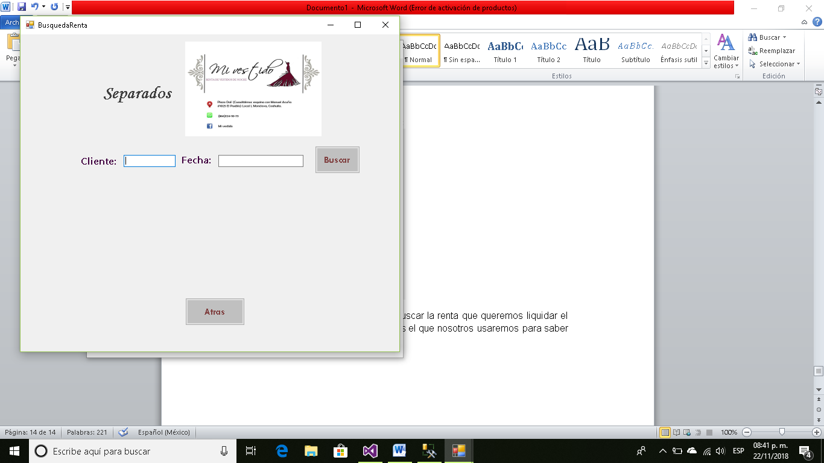

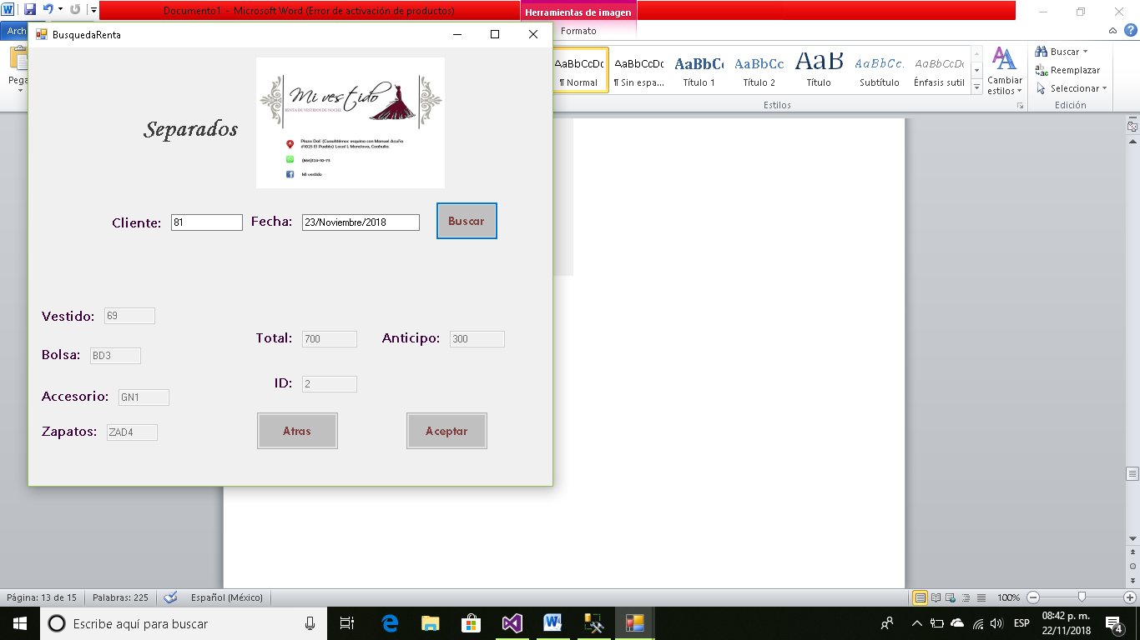

Código:

Imports System.Data.Sql

Imports System.Data.SqlClient

Public Class BusquedaRenta

Public idrenta As String

Public anticipo As String

Public total As String

Private Sub BusquedaRenta_Load(sender As Object, e As EventArgs) Handles MyBase.Load

abrir()

End Sub

Private Sub Button1_Click(sender As Object, e As EventArgs) Handles Button1.Click

Dim idvest As String

Dim idacc As String

Dim idbolsa As String

Dim idzap As String

Label3.Visible = True

Label6.Visible = True

Label7.Visible = True

Label2.Visible = True

Label8.Visible = True

Label9.Visible = True

Label10.Visible = True

TextBox3.Visible = True

TextBox7.Visible = True

TextBox8.Visible = True

TextBox9.Visible = True

TextBox4.Visible = True

TextBox5.Visible = True

TextBox6.Visible = True

Button4.Visible = True

Query = "select Id_Vest, Id_Rent, Id_Acc, Id_Bolsa, Id_Zap, Tot_Rent, Anticipo from Anticipos where Id_Cl='" & TextBox1.Text & "' and Fecha_Rent='" & TextBox2.Text & "' "

cmd = New SqlClient.SqlCommand(Query, cnn)

cmd.ExecuteNonQuery()

Dim reader As SqlDataReader = cmd.ExecuteReader

reader.Read()

idvest = reader(0)

idrenta = reader(1)

idacc = reader(2)

idbolsa = reader(3)

idzap = reader(4)

total = reader(5)

anticipo = reader(6)

TextBox3.Text = idvest

TextBox6.Text = idrenta

TextBox8.Text = idacc

TextBox7.Text = idbolsa

TextBox9.Text = idzap

TextBox4.Text = total

TextBox5.Text = anticipo

End Sub

Private Sub Button4_Click(sender As Object, e As EventArgs) Handles Button4.Click

Liquidacion.TextBox2.Text = idrenta

Liquidacion.TextBox4.Text = total - anticipo

Liquidacion.TextBox5.Text = anticipo

Liquidacion.Show()

Me.Close()

End Sub

Private Sub Button2_Click(sender As Object, e As EventArgs) Handles Button2.Click

Liquidacion.Show()

Me.Close()

End Sub

End Class

Automáticamente me llene el ID de Renta, el anticipo y el total de renta.

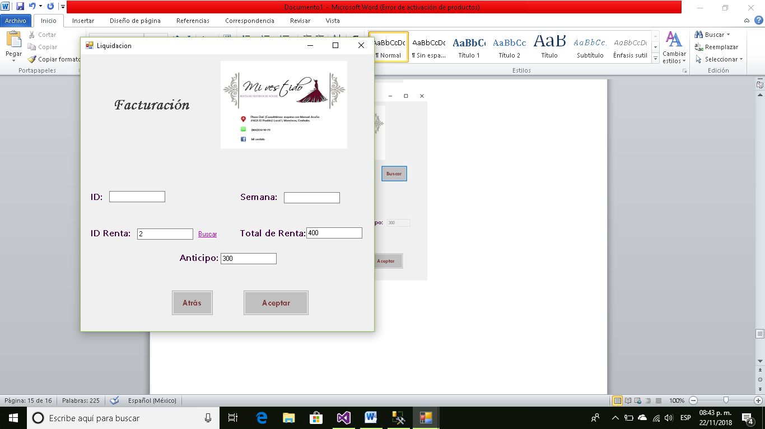

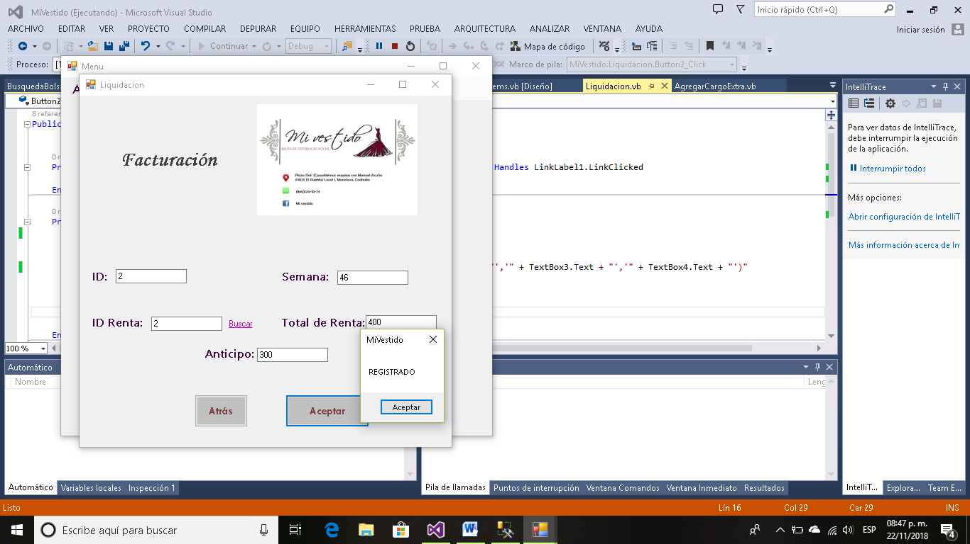

**Ventana Pago Empleados.**

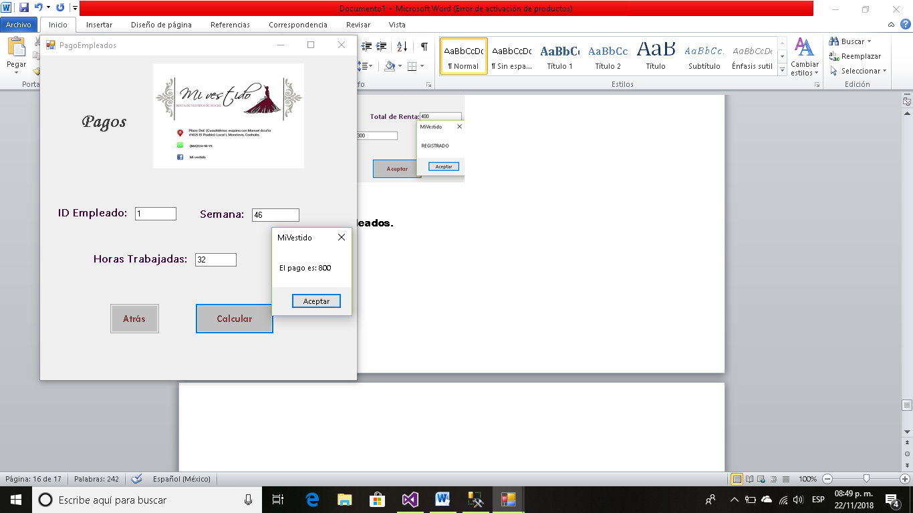

Código:

Imports System.Data.Sql

Imports System.Data.SqlClient

Public Class PagoEmpleados

Private Sub Button2_Click(sender As Object, e As EventArgs) Handles Button2.Click

Query = "select PagoH_Emp from Empleados where Id_Emp='" & TextBox8.Text & "'"

cmd = New SqlClient.SqlCommand(Query, cnn)

cmd.ExecuteNonQuery()

Dim reader As SqlDataReader = cmd.ExecuteReader

reader.Read()

Dim Pago As Integer

Pago = reader(0)

Dim horas As Integer = Convert.ToInt32(TextBox1.Text)

Dim Total = Pago * horas

MsgBox("El pago es: " & Total)

reconectar()

Query = "insert into Asistencia values ( '" + TextBox3.Text + "','" + TextBox8.Text + "','" + TextBox1.Text + "')"

cmd = New SqlClient.SqlCommand(Query, cnn)

cmd.ExecuteNonQuery()

cnn.Close()

MsgBox("REGISTRADO")

End Sub

Private Sub PagoEmpleados_Load(sender As Object, e As EventArgs) Handles MyBase.Load

abrir()

End Sub

Private Sub Button1_Click(sender As Object, e As EventArgs) Handles Button1.Click

Form1.Show()

Me.Close()

End Sub

End Class

**Ventana Corte Semanal.**

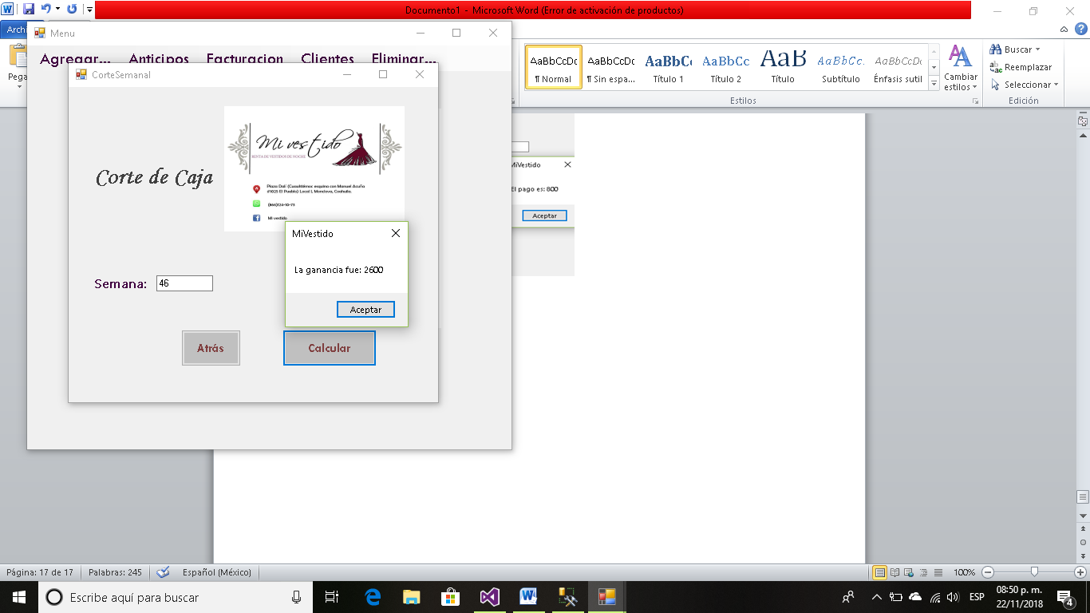

Código:

Imports System.Data.Sql

Imports System.Data.SqlClient

Public Class CorteSemanal

Private Sub Button2_Click(sender As Object, e As EventArgs) Handles Button2.Click

Dim TotalR As Integer

Dim TotalA As Integer

Query = "select sum(a.Anticipo) as TotalAnticipo, sum(f.total) as TotalLiquidaciones from Anticipos as A, Factura as F where a.semana='" & TextBox3.Text & "' and f.semana='" & TextBox3.Text & "' "

cmd = New SqlClient.SqlCommand(Query, cnn)

cmd.ExecuteNonQuery()

Dim reader As SqlDataReader = cmd.ExecuteReader

reader.Read()

TotalR = reader(0)

TotalA = reader(1)

Dim total = TotalR + TotalA

MsgBox("La ganancia fue: " & total)

End Sub

Private Sub CorteSemanal_Load(sender As Object, e As EventArgs) Handles MyBase.Load

abrir()

End Sub

End Class

Ahora vamos con las opciones que tenemos en los clientes.

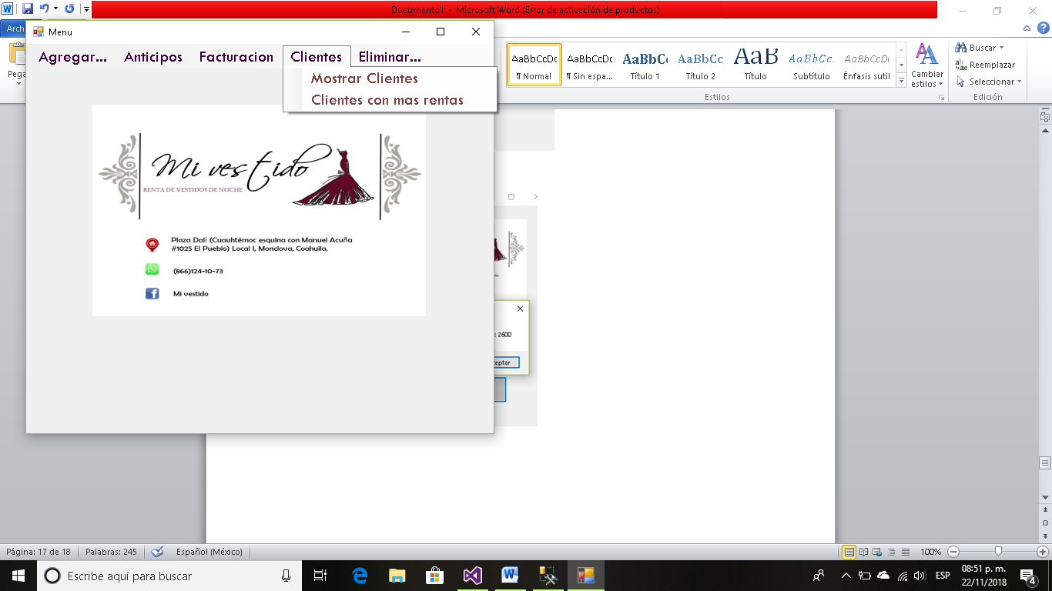

**Opción Mostrar Clientes.**

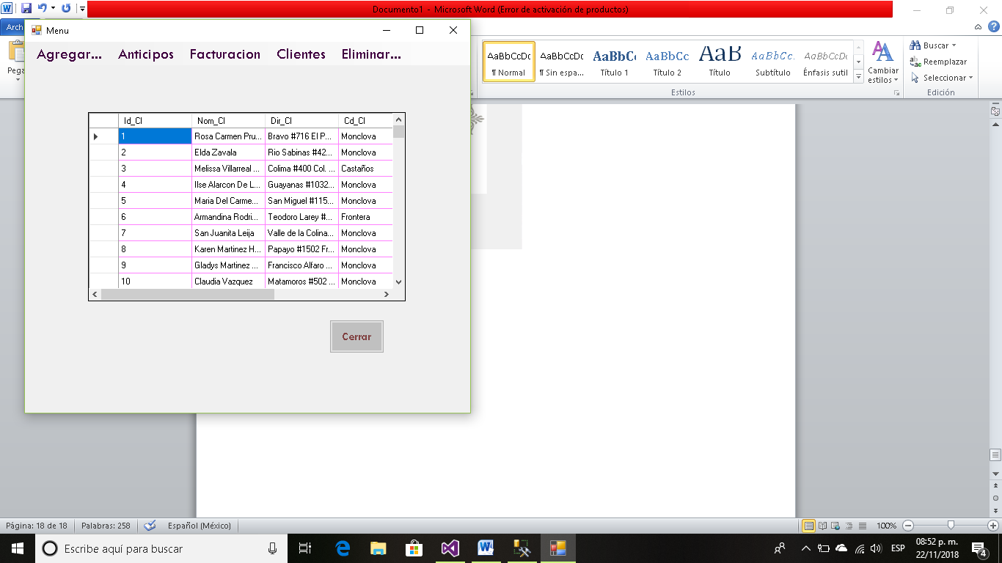

**Opción Clientes con más Rentas.**

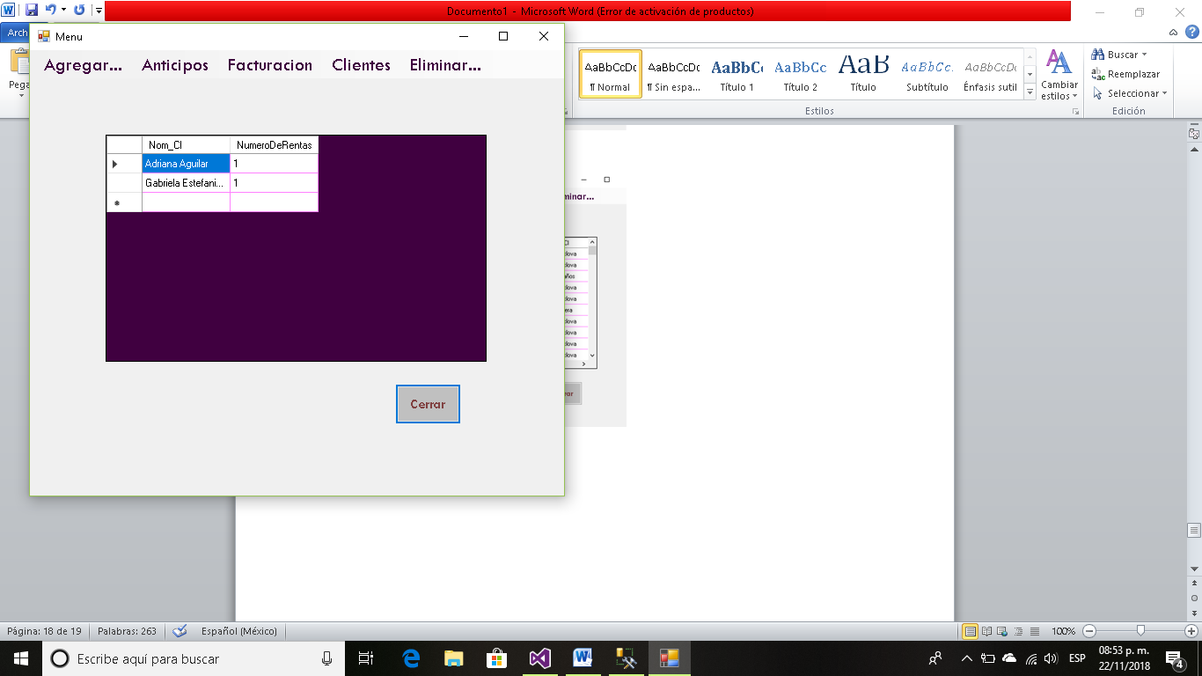

También contamos con la opción de eliminar ya sea Bolsas, Vestidos, Accesorios, Zapatos o Empleados.

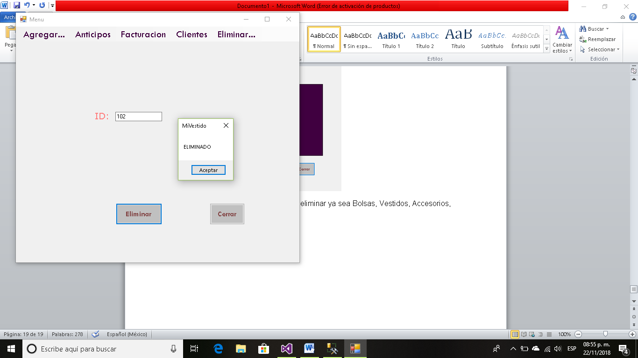

**Todas las opciones que se realizaron en el FORM1 están en el código de este, en la primera ventana.**